Zebrafish Breeding Protocol

Step 1: If you plan on setting up breeding tanks at 3 or 4 o’clock in the afternoon, ensure that the fish are not fed past 1:00 pm (approx. 3 hours prior to breeding setup). Please indicate which tanks you wish to breed on the calendar AND on the tanks themselves with the date. This ensures others don't use the same fish for breeding days later.

Step 2: For optimal breeding it is best to use the small fish tanks. As a result, determine the number of fish tanks you would like to set up and fill them up ¾ with system water from the rack.

Step 3: Place the plastic filter (with the smallest pores) into each small tank to prevent the eggs from slipping through. Add some artificial plants as well as some marbles to the fertilization tank (small tank with holes in the bottom). It is important to add the artificial plants since the fish like to breed in unexposed/hidden areas.

Step 4: From the larger tanks, net two adult males and one adult female fish (or 4 males 2 females) into the small tank. To determine the gender of the fish, refer to the page attached.

Step 5: After this is complete, place the fish tank on the rack and turn on the water so that it is gently flowing through.

Step 6: After approx 16-20 hours it is time to collect the eggs. In order to determine if eggs are present you will see very small transparent spheres at the bottom of the tank.

Step 7: Turn the water off and net the adult Zebrafish back into their original tanks. Set up another small tank that is filled with approx 3-4 cm of system water. We will call this tank A.

Step 8: Using a Zebrafish egg filter, gently pour all the water from the tank containing the eggs through the filter and allow the water to drain into the sink. Note: It is important to pour the water gently so that the eggs do not get crushed by the force of the water.

Step 9: After all of the water has been poured, rinse the bottom of the tank to wash any eggs that may be sticking to the tank and pour them through the filter gently. Immediately after the eggs from each respective breeding tank have been poured into the filter, place the filter in tank A so that the eggs do not die. Once you are done collecting the eggs, pipette them using a transfer pipette into a clean sterile petri dish.

Step 10: After the eggs are collected, they need to be sorted. Sorting entails moving the good, fertile embryos/eggs into a new dish away from the infertile eggs and any debris that is in the dish (scales, waste products of the fish, etc.). Fertile embryos will always look transparent. Under the microscope you will be able to see living cell. They will often just stay stuck at the one cell stage, and then later they will look like big dark masses inside a chorion.

Step 11: Use a plastic disposable transfer pipette or a P1000 pipette to remove the debris.

Step 12: Before injecting and/or adding the embryo’s to E3 (embryo water) water, it is essential to make sure the embryo’s are clean. This step must be done before the embryos hatch and is best done right after collecting the eggs. For this step, you will need to remove most of the water that is already present in the petri dish and replace the water in the petri dish with approx5 mL of embryo bleach 0.003%. ONLY LET THE BLEACH SIT FOR 15-30 SECONDS!! Then you will need to quickly remove most of the bleach and add filtered E3 to the eggs. This step is very important to ensure no bacteria or fingus will grow in the water. If you are doing drug response experiments it is essential to make sure that there is nothing in the water to interact/interfere with the drugs being added.

Step 13: Now that the eggs are clean, you may proceed to the injection protocol or if you decide to inject at a later date the embryo’s should be stored in an incubator or heat block set at 28 ºC.

Zebrafish Gender Identification Guidelines

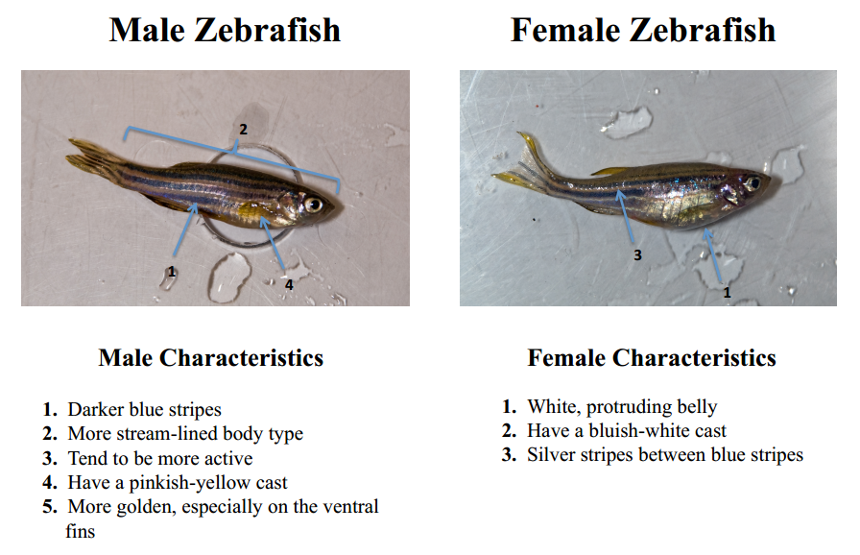

Image adapted from: http://www.zfic.org/common%20techniques/Gender%20identification%20guide.pdf)

